Are you a woman that loves helping children
and schools,
your local library, recycling and the
environment,
and serving your community?
Look no further!
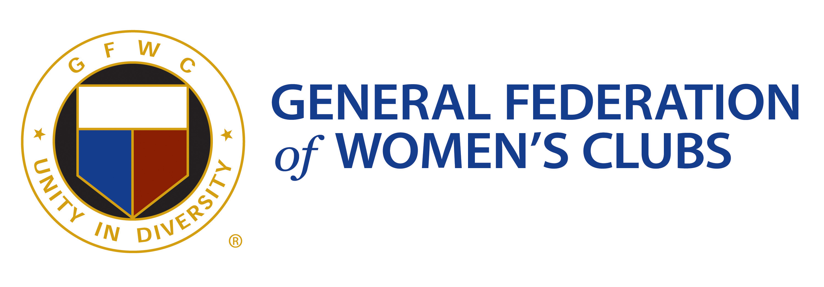

The General Federation of Women’s Clubs is an international women’s organization dedicated to community improvement by enhancing the lives
of others through volunteer service.

We are in your community and would enjoy having you join us in service!

Contact a West Virginia club:
On the web at GFWCWestVirginia.org- email us
Like us on Facebook at GFWC West Virginia –
send a message

